This project examines how the concept of “price” is constructed and varied across a corpus of early modern economic texts. Rather than treating “price” as a stable economic term, I analyze it as a contextual concept whose meaning changes depending on surrounding words, named entities, and broader discussions of money, exchange, trade, and commodities. My central question is: how does “price” function across the corpus, and what different meanings or uses does it take on in different contexts? I argue that “price” in this corpus is not divided into completely separate meanings. Instead, it moves between two overlapping uses: price as valuation, meaning the worth or assessed value of commodities, and price as market exchange, meaning a term connected to money, exchange rates, scarcity, trade, and circulation. The computational results show this overlap clearly: BERT clustering reveals some contextual groupings, but the logistic regression classifier struggles to separate the two meanings because the vocabulary around them is highly similar.
Step 1
I selected “price” as my conceptual keyword because it is central to early modern economic writing but does not always mean the same thing. Sometimes it refers to the value of a commodity, while in other contexts it is connected to exchange, scarcity, money, and international trade. I extracted occurrences of “price,” “prices,” and “priced” from the corpus and used the sentence containing the keyword as the unit of analysis. This produced 2,246 total occurrences. Most occurrences came from the form “price,” while “prices” appeared less often and “priced” appeared only once. Unfortunately, only 17 out 23 texts present the word, and the occurrences are unevenly distributed among the top 6 texts. One document contains a much larger number of occurrences than the others. This text, as we discussed in class, is longer than the rest of the text and thus produced more occurrences.

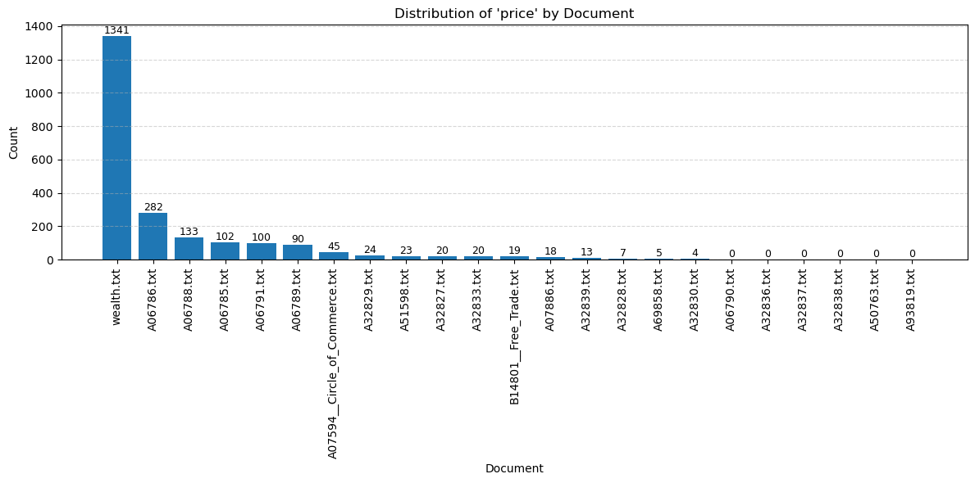Figure 1. Distribution of “price” by document
Figure 1 shows that the concept is not evenly distributed across the corpus. This uneven distribution suggests that “price” is a central term in some economic texts but only marginal in others.
Step 2
I focused on GPE, LOC, ORG, PERSON, and MONEY entities. The most frequent entities around “price” after NER show that ORG has the most frequent occurrences, include Exchange, Trade, commodities, and Bills, while the two entities that represent places appear more times, such as England, Europe, France, London, Holland, Spain, India, and Scotland. I think geographics has stronger pattern in this case. These results suggest that “price” is strongly connected to geography and market circulation. It is not only discussed as a description of how goods are exchanged, but also as something relevant to the economic behavior itself. This distinction has laid the foundation for the latter analysis of the meaning.
However, as could see from the list, some verbs such as ““Trade,” “Exchange,” and nouns “Cloth,” and “wares” are identified as entities.
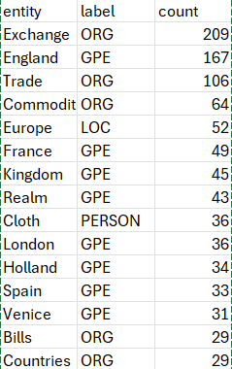
Table 1. Top Named Entities Around “Price”
Step 3
To examine contextual meaning, I used BERT to generate embeddings for each occurrence of “price,” “prices,” and “priced.” Unlike a simple word count, BERT represents the word according to its sentence context but not a simple word count, so this allows the same word to have different vector representations when it appears in different contexts. I then used KMeans clustering to group similar contexts and UMAP to visualize the structure of the embeddings. The silhouette k test indicates that k =3 is ideal but conceptually, I prefer distinction I observe from the NER method. I cluster under two k. I will not detail the interpretation here and choose the k =2 directly.
To better interpret the BERT clusters, I used TF-IDF to identify the most distinctive terms in each cluster. These terms help show what kinds of contexts surround the word “price” in different parts of the corpus.
For Cluster 0, the most distinctive terms include “shillings,” “paid,” “sell,” “pound,” “reckoned,” “cost,” “sold,” “pounds,” and “pence.” These words suggest that this cluster is strongly associated with concrete monetary transactions. The presence of currency terms such as “shillings,” “pound,” “pounds,” and “pence” shows that “price” is often used in relation to payment, calculation, and monetary units. Words such as “paid,” “sell,” “sold,” and “cost” further suggest that this cluster treats price as something involved in actual exchange or commercial transaction. Therefore, I interpret Cluster 0 as representing a more transactional or monetary-exchange meaning of “price.”
For Cluster 1, the most distinctive terms include “labor,” “rise,” “commodities,” “real,” “corn,” “money,” “market,” “raise,” “natural,” “home,” and “provisions.” These terms suggest a broader economic discussion of price. Instead of focusing mainly on payment or currency units, this cluster connects price to labor, commodities, market conditions, and the idea of “real” or “natural” value. Words such as “labor,” “real,” and “natural” suggest that this cluster may involve theoretical discussions about what determines the value of goods. At the same time, words such as “corn,” “commodities,” “provisions,” and “market” show that price is also connected to the availability and movement of goods.
However, these two meanings are not completely separate. Cluster 1 still includes “money,” and Cluster 0 still includes words such as “sell” and “cost,” which are also related to commodity value. The overlap is also displayed on the UMAP embeddings graph.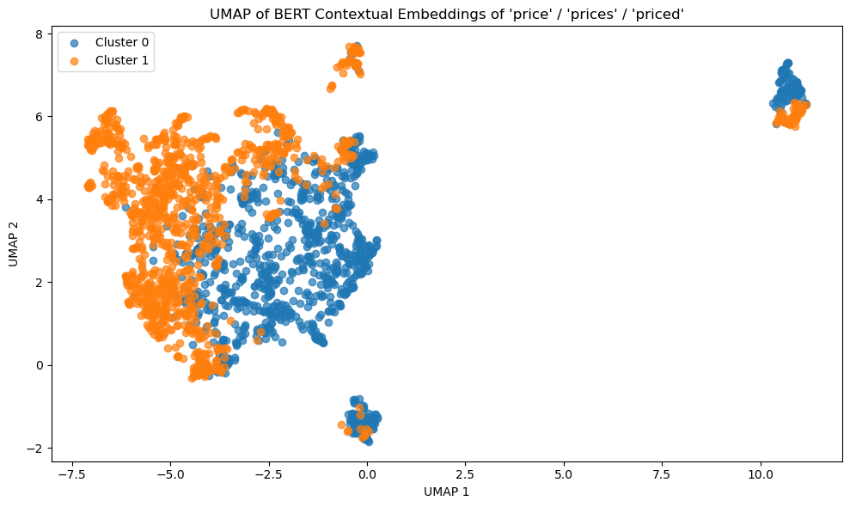
Figure 2. UMAP of BERT Contextual Embeddings
Figure 2 shows that BERT identifies some contextual structure, but the clusters still overlap. This supports the interpretation that the meanings of “price” are related rather than fully separate.
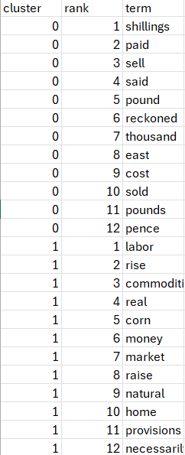
Table 2. Distinctive Terms by Cluster
Example:
Label 0
wealth.txt 7550 price "To depress the price of this commodity below what
may be called its natural and proper price, was the avowed purpose of
those regulations; and there seems to be no doubt of their having produced
the effect that was expected from them."
Label 1
A06785.txt 55 price Again, when the price of commodities is raised generally with the price of moneys enhanced; P. 25. shall we contradict the same, because one commodity, as Cloves, is not risen, but sold as a staple ware?
Step 4
I summarized two categories of meaning for price: maket_exchange and valuation. The market_exchange label refers to uses of “price” connected to circulated monetary number. The valuation label refers to uses of “price” as the assessed worth, value of goods or intrinsic value. I manually labeled 75 examples selected from k =3 BERT clusters. The results show that the dataset included 47 examples of market_exchange and 28 examples of valuation. I trained a logistic regression classifier using TF-IDF features from the sentence contexts. The purpose of this step was to test whether market_exchange and valuation are linguistically distinct enough for a model to learn the difference.
The classification results show that the model did not distinguish the two meanings well. In the test set, the model predicted all examples as valuation. It correctly classified the 9 valuation examples, but it misclassified all 14 market_exchange examples. As a result, the market_exchange class had precision, recall, and F1 scores of 0.00. The overall accuracy was 0.39, but this number is misleading because the model collapsed into one-sided prediction rather than learning a balanced distinction between the two categories.
This weak performance suggests that the two meanings of “price” are difficult to separate with TF-IDF features alone. The labels are conceptually different, but the actual language surrounding them overlaps heavily. Both categories include words related to money, commodities, exchange, value, scarcity, trade, and market conditions. Therefore, the model’s failure is not only a technical problem. It also supports the broader interpretation that “price” is a semantically entangled concept in this corpus.
For feature interpretation, I first tried an L1 logistic regression model, but most coefficients were reduced to zero. I therefore used an L2 logistic regression model to examine the general direction of association between terms and labels. The L2 model retained 1,678 non-zero features out of 2,541 total features. Negative coefficients were associated with market_exchange, while positive coefficients were associated with valuation.
The L2 feature results should still be interpreted cautiously. The features associated with market_exchange include terms related to foreign trade, abundance, scarcity, and exchange. These terms fit the interpretation that this category treats price as part of circulation and market movement. The features associated with valuation include terms related to years, yield, delivery, and price over time. These features suggest that the model sometimes connects valuation with calculation, assessment, and temporal comparison. However, because the classifier performed poorly overall, these feature weights should not be read as strong evidence of stable semantic boundaries. They are better understood as weak signals in a dataset where the two meanings remain highly overlapping.
Overall, Step 4 shows that supervised classification can test the interpretive categories, but it does not fully confirm a clean division between them. The model’s weak performance supports my central claim: in this corpus, “price” moves between valuation and market exchange, but these meanings are not clearly separated. Instead, they are connected through shared economic vocabulary and historical discussions of trade.
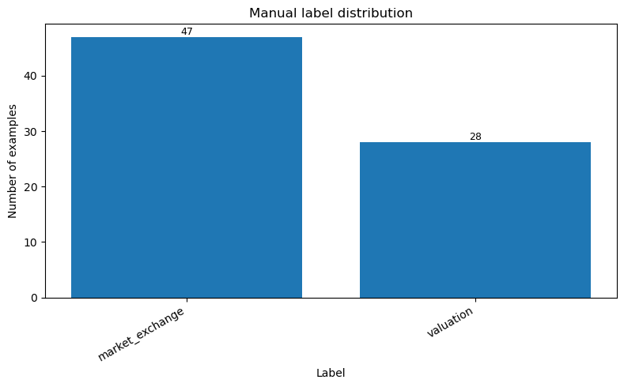
Figure 3. Manual Label Distribution
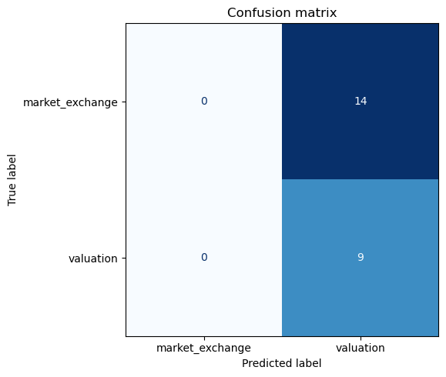
Figure 4. Confusion Matrix
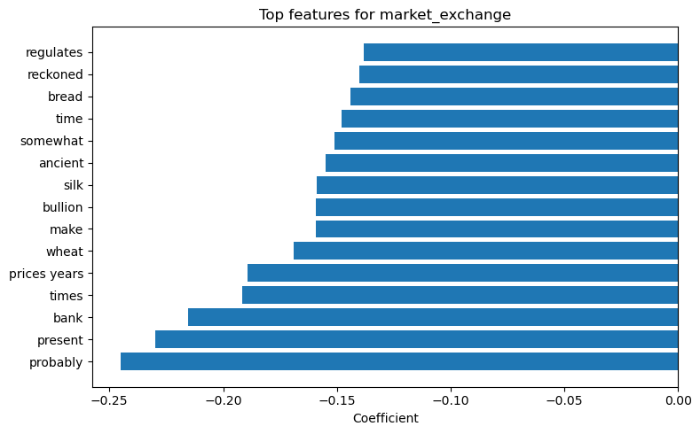
Figure 5. Top Features by market_exchange
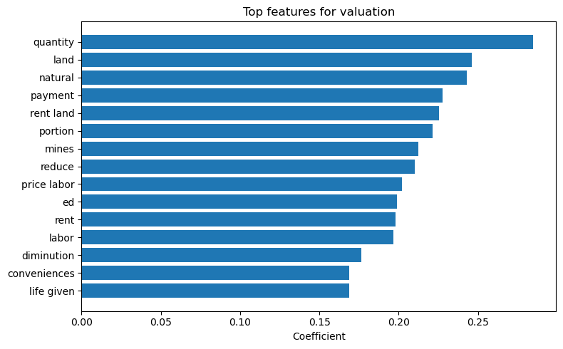Figure 6. Top Features by valuation
Step 5

Taken together, the results show that “price” has two major but overlapping meanings in the corpus. First, “price” functions as a term of valuation. In this use, it refers to the worth of commodities and is connected to labor, scarcity, production, and market conditions. Second, “price” functions as a term of market exchange, appears in discussions of money, exchange, payment, trade, and relations between countries.
The close reading complicates the apparent distinction between the two clusters. The TF-IDF terms suggest that the market_exchange contexts are often associated with words such as “pay,” “paid,” “sell,” “pound,” and “pence,” while the valuation contexts are more often associated with words such as “labor,” “market,” “commodities,” “real,” and “natural.” At first, this seems to support a distinction between price as monetary exchange and price as commodity valuation. However, the close reading shows that this distinction is not clean. Some valuation-oriented passages still use numerical or payment-related language, while some exchange-oriented passages still involve questions of value, scarcity, and market conditions.
This overlap may reflect the historical character of the corpus. In these early modern economic texts, the conceptual distinction between market price, exchange value, and intrinsic or natural value does not appear to be fully stabilized. Price is often treated both as a monetary amount paid in exchange and as an expression of the value of goods. Therefore, words such as “pay,” “paid,” or “pence” do not necessarily indicate a purely transactional meaning, just as words such as “labor,” “market,” or “commodities”. The same context can contain both meanings at once.
This finding helps explain why the classifier struggled: the problem is not only that the model failed to classify the examples, but that the meanings themselves are historically and linguistically intertwined.

Example. Top Overlapping Contexts:
"The commodity is then sold precisely for what it is worth, or for what it
really costs the person who brings it to market; for though, in common
language, what is called the prime cost of any commodity does not
comprehend the profit of the person who is to sell it again, yet, if he
sells it at a price which does not allow him the ordinary rate of profit
in his neighborhood, he is evidently a loser by the trade; since, by
employing his stock in some other way, he might have made that profit." cost, costs, sell, sold commodity, market, worth 7

